Analysing Disaster Recovery (DR) Architecture of GMA:

A disaster recovery plan is crucial for maintaining the continuity of your business operations in the event of an unforeseen disaster, such as a server failure, natural disaster, or cybersecurity attack:
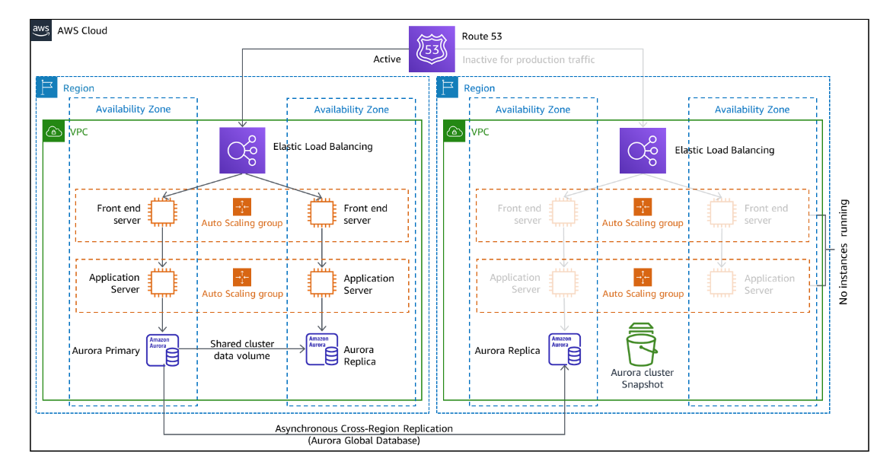

1. Backup and Restore
Overview: This is the simplest and most cost-effective method. It involves regularly backing up data to AWS (e.g., to Amazon S3) and restoring it when needed.
Suitable for: Businesses with a more flexible RTO and RPO.
AWS Services: Amazon S3 for storage, AWS Backup for managing backups, Amazon Glacier for long-term archival.
Considerations: While cost-effective, restoration times can be longer, making it less suitable for applications requiring quick recovery.
Implementing Backup and Restore
1. Amazon S3: Use Amazon Simple Storage Service (S3) for storing backups. S3 offers high durability and availability, making it ideal for backup storage.
2. AWS Backup: Automate backup policies across AWS services using AWS Backup. It provides a centralized place to manage backups and ensure compliance with your backup requirements.
3. Automation: Use AWS Lambda for automation of backup processes, like triggering backups based on certain conditions or schedules.

2. Pilot Light - Choice
Overview: Similar to a gas heater kept in a ready state, this method involves having a minimal version of the environment always running on AWS.
Suitable for: Businesses that need quicker recovery than backup and restore but can tolerate some delay in full-scale operation.
AWS Services: Amazon EC2 for critical core elements, AWS Database Migration Service for replicating databases, Amazon Route 53 for DNS routing.
Considerations: This strategy strikes a balance between cost and recovery time, keeping critical elements ready to scale up in an emergency.
Implementing Pilot Light
1. Amazon EC2: Use Amazon Elastic Compute Cloud (EC2) to run a minimal version of your critical services.
2. AWS Database Migration Service (DMS): Replicate your databases continuously with DMS, which can be scaled quickly in a DR event.
3. Amazon Route 53: Manage DNS and traffic routing to switch between your main site and the AWS environment when needed.

3. Warm Standby
Overview: A more robust version of the pilot light where a scaled-down but fully functional version of your environment is always running on AWS.
Suitable for: Businesses requiring rapid recovery (short RTO) but can manage with a smaller capacity immediately after a disaster.
AWS Services: Amazon EC2, Auto Scaling to quickly scale, Elastic Load Balancing for distributing traffic.
Considerations: More expensive than Pilot Light due to running resources but provides faster recovery.

Implementing Warm Standby
1. Auto Scaling: Implement Auto Scaling to automatically adjust the capacity of your standby environment to maintain steady performance.
2. Elastic Load Balancing (ELB): Use ELB to distribute incoming application traffic across multiple targets, such as Amazon EC2 instances, in multiple Availability Zones.
3. AWS CloudFormation: Utilize CloudFormation to manage and provision a collection of related AWS resources, enabling quick deployment and management of infrastructure.

4. Multi-Site
Overview: This involves running your environment in multiple AWS regions simultaneously. In case of a disaster, traffic is rerouted to the unaffected site.
Suitable for: Businesses that require near-zero downtime (very low RTO) and no data loss (low RPO).
AWS Services: Amazon Route 53 for DNS routing, Amazon CloudFront for global content delivery, replication across multiple AWS regions.
Considerations: This is the most expensive option but offers the highest availability and fastest recovery.
Implementing Multi-Site
1. Cross-Region Replication: Set up cross-region replication for services like Amazon S3 and Amazon RDS to maintain up-to-date copies of data in multiple AWS regions.
2. Amazon CloudFront: Leverage Amazon CloudFront for global content delivery and to route users to the nearest operational region.
3. Amazon Route 53 Health Checks: Configure health checks and DNS failover in Route 53 to automatically route traffic away from an affected region.

Set Up Data Replication:
Amazon RDS/Aurora Replication
1. Overview: Amazon Relational Database Service (RDS) and Amazon Aurora provide features for replicating databases across different regions.
2. Cross-Region Replication: This feature enables you to have a standby replica of your database in a different geographic location.
- Amazon RDS: Use the cross-region snapshot feature to copy snapshots to other regions and recover your database.
- Amazon Aurora: Aurora offers cross-region replication where you can have read replicas of your primary database in different regions.
Amazon S3 Replication
1. Cross-Region Replication (CRR): Automatically replicates data across AWS regions. It’s useful for geographically diversifying your data to meet compliance requirements and for minimizing latency.
2. Same-Region Replication (SRR): Useful for aggregating logs or data into a single S3 bucket within the same region.

Amazon EBS Snapshots
1. Snapshotting: Amazon Elastic Block Store (EBS) provides the ability to create snapshots of your volumes, which can be replicated across regions.
2. Automated Snapshots: Automate snapshot creation and replication using Amazon Data Lifecycle Manager (DLM).

1. AWS CloudFormation:
Purpose: Automates the setup of AWS resources. You can create templates to quickly redeploy your infrastructure.
Use Case: Rebuild your entire infrastructure stack in a different region post-disaster.
2. AWS Lambda:
Purpose: Serverless compute service to run code in response to events.
Use Case: Trigger recovery scripts automatically when a disaster is detected.
3. Amazon CloudWatch:
Purpose: Monitoring service for AWS cloud resources and applications.
Use Case: Monitor AWS services and trigger automated recovery actions based on predefined metrics and alarms.

